Task 1

1. Install Jupyter notebook and run the first program and share the screenshot of the output.

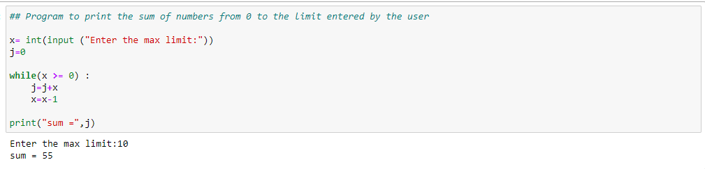

1. Write a program which will find all such numbers which are divisible by 7 but are not a multiple of 5, between 2000 and 3200 (both included). The numbers obtained should be printed in a comma-separated sequence on a single line.

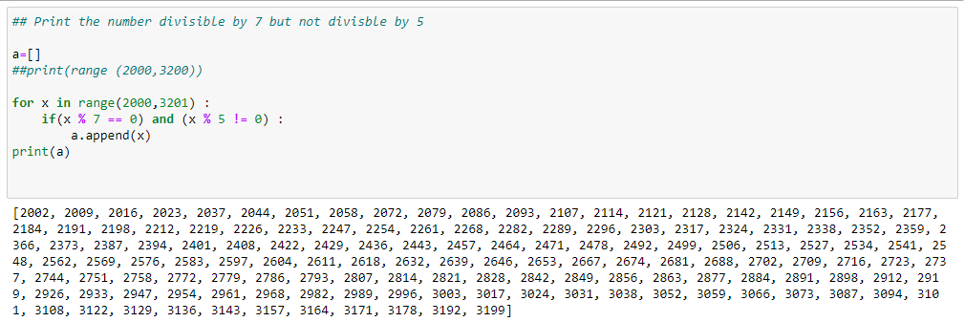

1. Write a Python program to accept the user's first and last name and then getting them printed in the reverse order with a space between first name and last name.

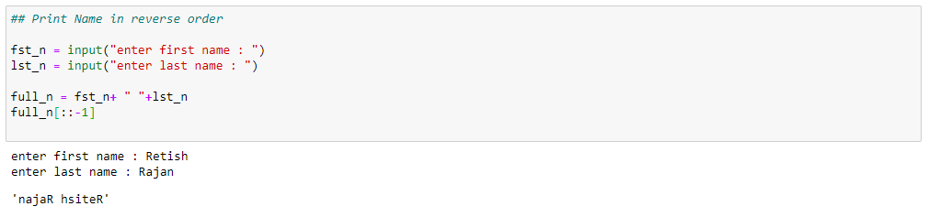

1. Write a Python program to find the volume of a sphere with diameter 12 cm.

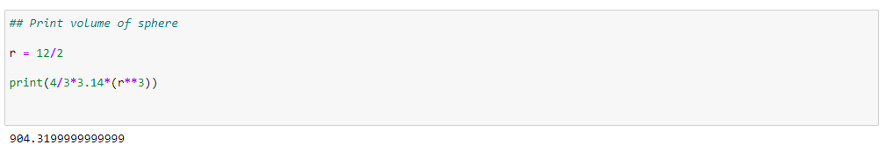

Task2

1. Write a program which accepts a sequence of comma-separated numbers from console and generate a list

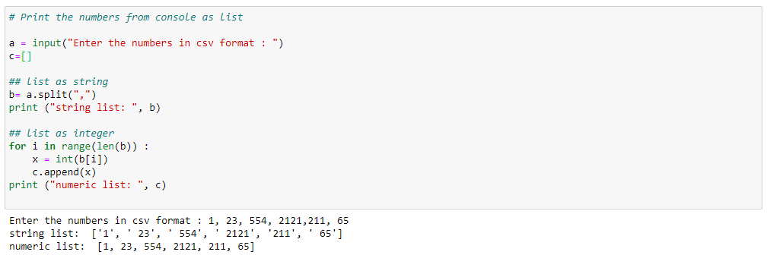

1. Create the below pattern using nested for loop in Python.

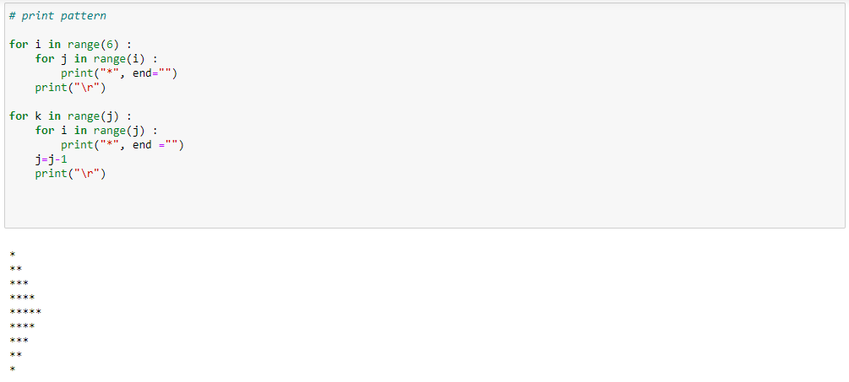

1. Write a Python program to reverse a word after accepting the input from the user.

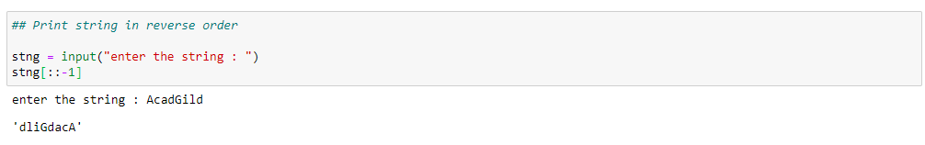

1. Write a Python Program to print the given string in the format specified in the sample output.

